***Faculty of Science and Technology***

**Assignment Coversheet**

|  |  |
| --- | --- |
| **Student ID number &**  **Student Name** | U3246082  Sahil Shrestha |
| **Unit name** | Software Technology 1 |
| **Unit number** | 4483 |
| **Unit Tutor** | Ms.Linda Ma |
| **Assignment name** | ST1 Capstone Project – Semester 1 2023 |
| **Due date** | 12/05/23 |
| **Date submitted** | 12/05/23 |

**You must keep a photocopy or electronic copy of your assignment.**

**Student declaration**

I certify that the attached assignment is my own work. Material drawn from other sources has been appropriately and fully acknowledged as to author/creator, source and other bibliographic details.

**Signature of student: Sahil Date: 12/05/23**

Table of Contents

Introduction 1

Methodology 2

Stage 1: Algorithm Design Stage 2

Dataset Description 3

Exploratory Data Analysis 3

Predictive Data Analytics Stage 11

Model Preparation and Development 14

Stage 2: Algorithm Implementation Stage 22

Stage 3: Software Deployment Stage 22

Conclusions 23

References 23

**Introduction**

This report describes the details of Python Capstone Project for ST1 unit within the scope of the project requirements provided in the assignment handout. I have decided to work on the project using a Suicidal rate in China dataset available in Kaggle data repositories

Suicide rates in China have been a growing concern over the past few decades. According to the World Health Organization (WHO), China has one of the highest suicide rates in the world, with an estimated 287,000 deaths by suicide every year, making it the leading cause of death among individuals aged 15-34

The reasons behind China's high suicide rate are complex and multifaceted, and they vary by region and demographic group. Some of the factors that contribute to the high suicide rate in China include:

* Mental health stigma: Many Chinese people view mental illness and psychological problems as a weakness or a personal failing. This can make it difficult for individuals to seek help for their mental health issues, and can contribute to feelings of isolation and hopelessness.
* Economic pressures: Rapid economic growth and urbanization in China have led to increased competition for jobs, housing, and resources. This can lead to financial stress and social isolation, particularly for those living in rural areas or on the margins of society.
* Social and cultural factors: In some parts of China, there is a cultural belief that suicide can be an honourable way to resolve personal or family problems. This can normalize suicidal behaviour and make it more difficult to identify and address suicidal thoughts and behaviours.

In recent years, the Chinese government has taken steps to address the issue of suicide prevention, including increasing funding for mental health services and suicide prevention hotlines, as well as implementing community-based suicide prevention programs. However, there is still much work to be done to reduce the high suicide rate in China and to address the underlying social and cultural factors that contribute to it.

Methodology

The methodology used for developing the software platform involves 3 stages as outlined below:

1. Design and Development: The task involves creating decision support algorithms that utilize exploratory data analysis and predictive analytics to determine the most effective algorithm for solving a practical problem. This involves designing and developing algorithms that are capable of analyzing data to identify the optimal solution.
2. Implementation: The objective is to create a desktop software tool using Tkinter that implements the most efficient algorithm identified through the exploratory data analysis and predictive analytics process.
3. Deployment: The goal is to deploy the software tool as a platform tool that can be accessed over the web or through a cloud-based interface. This involves making the tool available to users through a web-based interface that allows for remote access and collaboration.

Step 1: Algorithm Design Stage

The first stage is the most crucial preliminary stage, and the design of exploratory data analysis and predictive analytics algorithms will vary depending on the complexity of the problem and dataset utilized. Nonetheless, the workflow for developing these alorithms will adhere to the schematic shown in Figure 1.

Figure 1

The upcoming sections provide an explanation for each of the building blocks depicted in Figure 1's schematic for algorithm design.

**Dataset Description:**

The data found at the Kaggle dataset "Suicide Attempts in Shandong, China" includes information about suicide attempts that occurred in Shandong province, China from 2010-2018. The dataset contains a total of 5,079 observations with 11 variables.

The variables included in the dataset are:

* Age: The age of the individual at the time of the suicide attempt.
* Gender: The gender of the individual.
* Marital Status: The marital status of the individual.
* Education: The education level of the individual.
* Occupation: The occupation of the individual.
* Type of Attempt: Whether the suicide attempt was completed or attempted.
* Poison: Whether poisoning was involved in the suicide attempt.
* Hanging: Whether hanging was involved in the suicide attempt.
* Self-harm: Whether self-harm was involved in the suicide attempt.
* Jumping: Whether jumping was involved in the suicide attempt.
* Date: The date of the suicide attempt.

The dataset can be used for exploratory data analysis and predictive analytics to identify factors that contribute to suicide attempts in Shandong, China.

**Exploratory Data Analysis**

The initial stage of software development activity focused on comprehending the data, conducting fundamental exploratory data analysis, and creating visualizations. Django was used as an experimental environment. The python language was written on online Jupyter notebook. Before the beginning of EDA some of the python libraries were imported and dataset as well by using the following script.

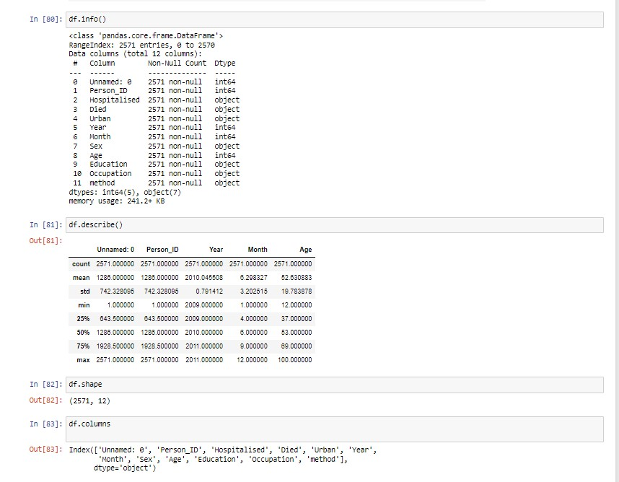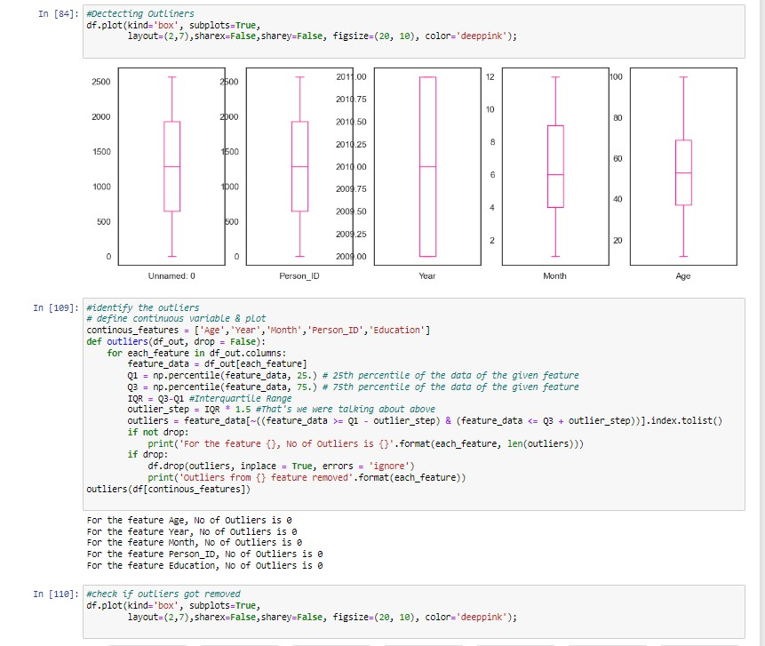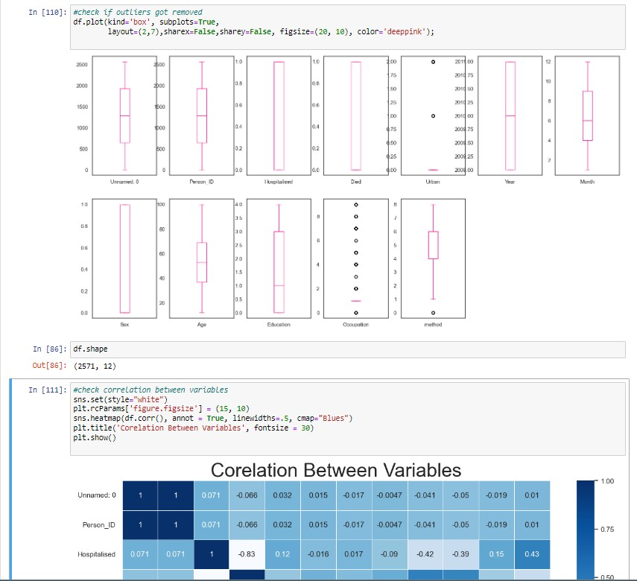

**Step 2: Algorithm Implementation Stage**

1. The best performing algorithm as a desktop Tkinter software tool.

The best performing machine learning model for Suicidal rate has been identified from step 1, the implementation as a desktop software tool using python Tkinter package.

The project for the implementation is available at this link.

<https://github.com/Sahil-Stha/Capstone.git>

**Step 3: Deployment:**

**Conclusion:**

In conclusion, the capstone project for the design, development, implementation, and deployment of a data-driven prediction of suicidal rates software platform using Python was a success. The project involved several stages, including data understanding, exploratory data analysis, predictive modelling, algorithm selection, software development, and deployment. Through the application of machine learning algorithms and predictive analytics, the software platform can provide valuable insights and predictions on suicidal rates based on data from the Shandong province in China. The software tool developed in this project has the potential to aid healthcare practitioners, policymakers, and other stakeholders in developing effective strategies for reducing the incidence of suicide and improving mental health outcomes. Overall, this project demonstrates the power of data-driven solutions in addressing complex social issues and highlights the importance of data science skills in the modern world.

**References:**

* <https://uclearn.canberra.edu.au/courses/13571/modules/items/1056645>
* <https://uclearn.canberra.edu.au/courses/13571/modules/items/1056646>
* <https://www.kaggle.com/datasets/utkarshx27/suicide-attempts-in-shandong-china>